

**AMERICAN INTERNATIONAL UNIVERSITY-BANGLADESH (AIUB)**

**Department of CSE**

**Computer Aided Design and Drafting**

**Section: L**

**Experiment No: # 01**

**Name : Khan, Md. Sazzad**

**Id : 22–49172-3**

Supervised by **: MD. RAKIBUL ISLAM CHOWDHURY**

**Name of Experiment** : Introduction to Engineering Drawing and Computer-Aided Design & Drafting and Familiarization with AutoCAD software and its different features.

**AutoCad Comments:**

1. **How To Change Background Color In AutoCad :**

**Type options >> Enter Key >> Display >> Colors >> Context : 2D model space >> Interface element : Uniform background >> Color : Choose Color >> Apply & Close**

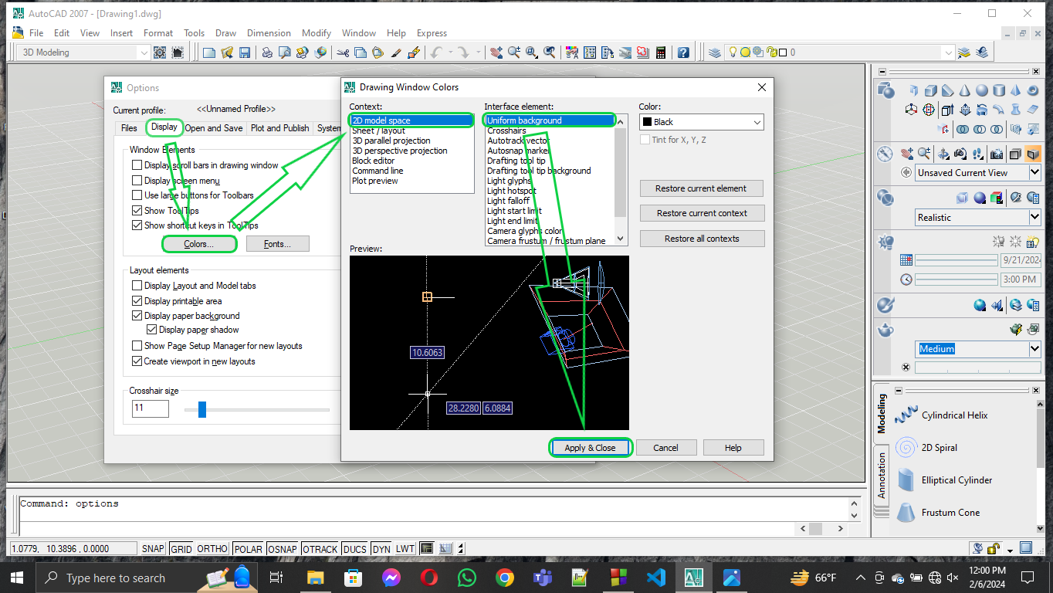

1. **How To Increase or Decrease CrossHair Size In AutoCad :**

**Type options >> Enter Key >> Display >> Increase or Decrease Crosshair size(Bottom) >> OK**

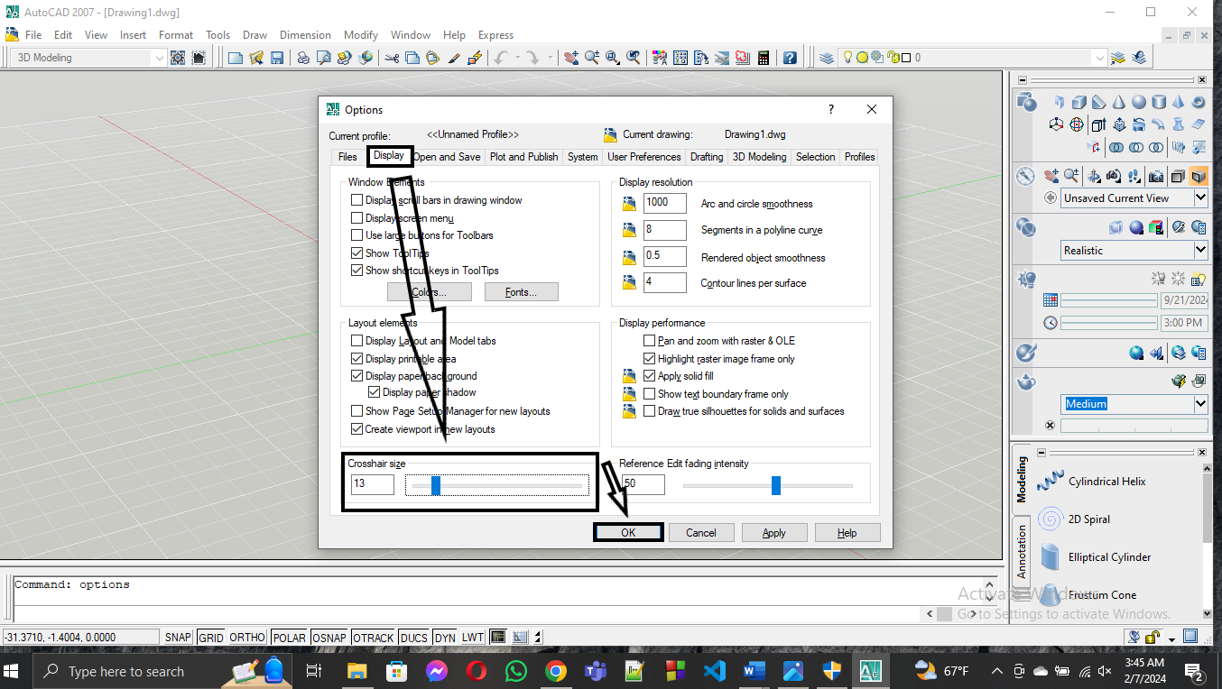

1. **How To Increase or Decrease Auto Snap Marker Size In AutoCad :**

**Type options >> Enter Key >> Drafting >> Increase or Decrease Auto Snap Marker Size(Middle) >> OK**

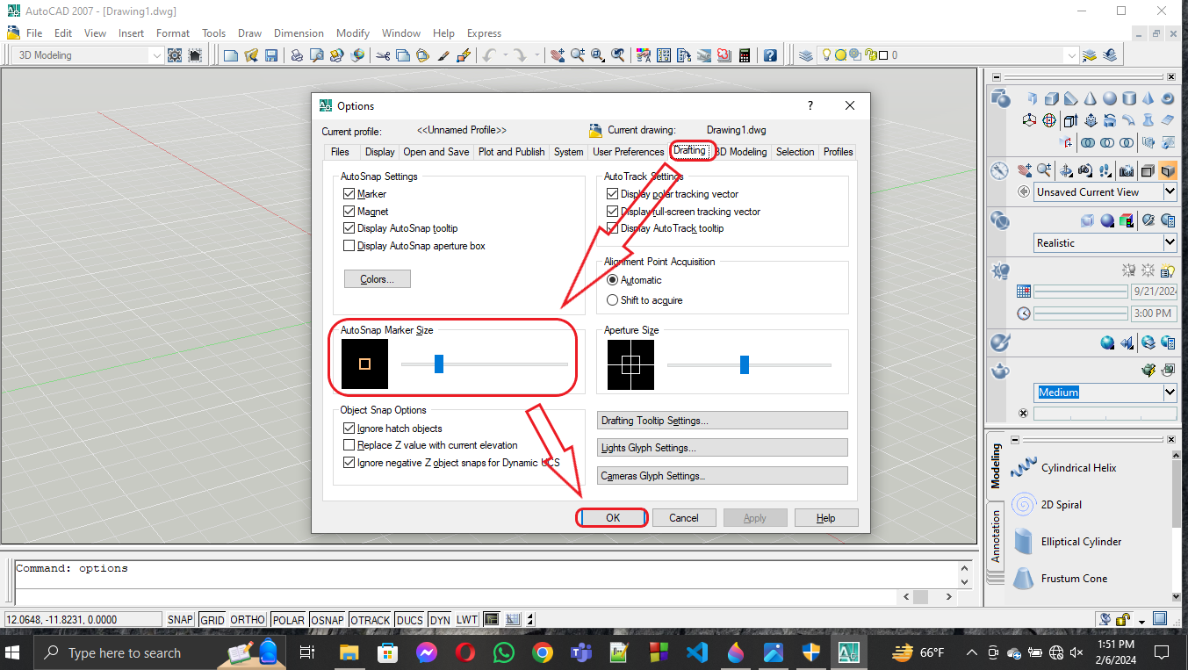

1. **How To Increase or Decrease Aperture Size In AutoCad :**

**Type options >> Enter Key >> Drafting >> Increase or Decrease Aperture Size(Middle) >> OK**

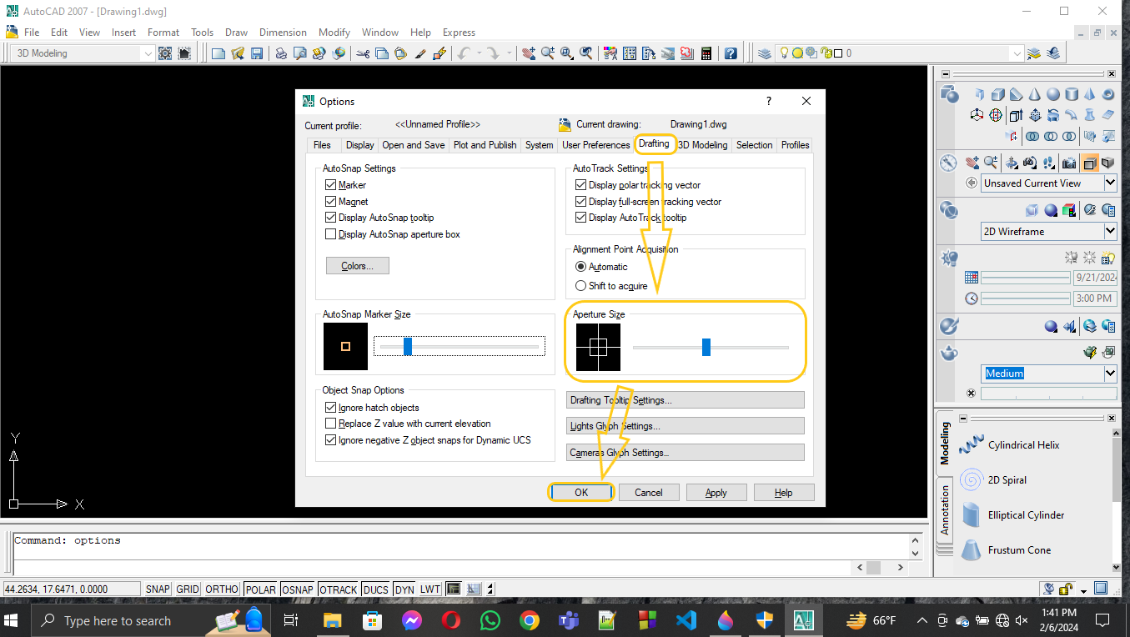

***Room View:***

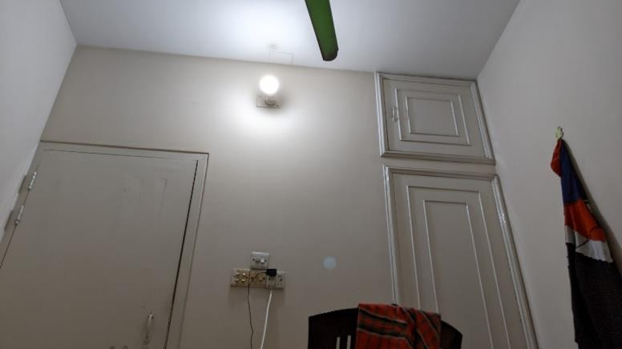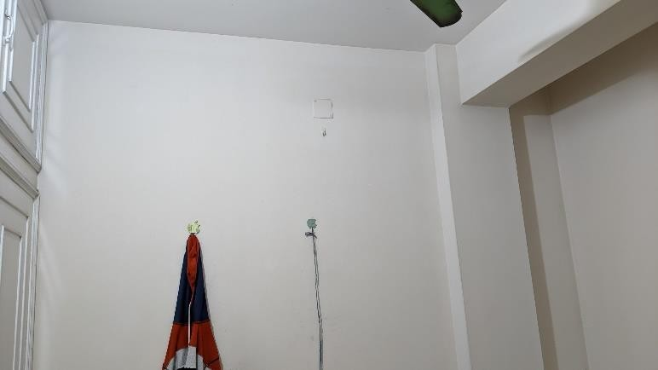

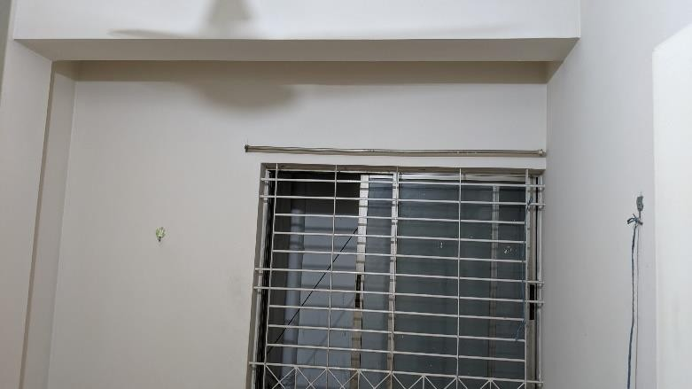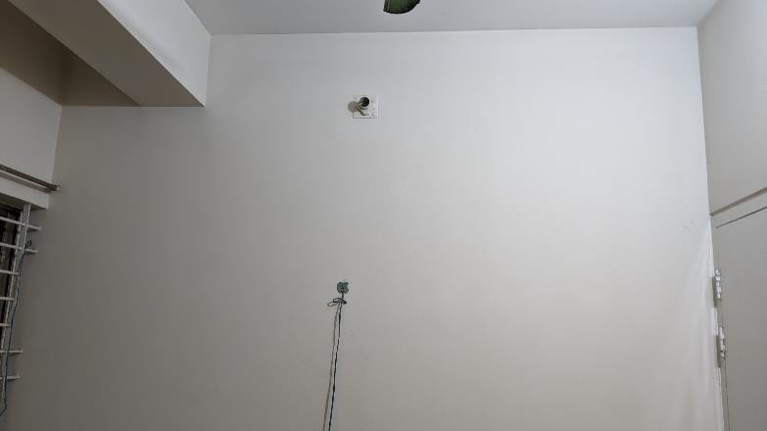

***Room Structure:***

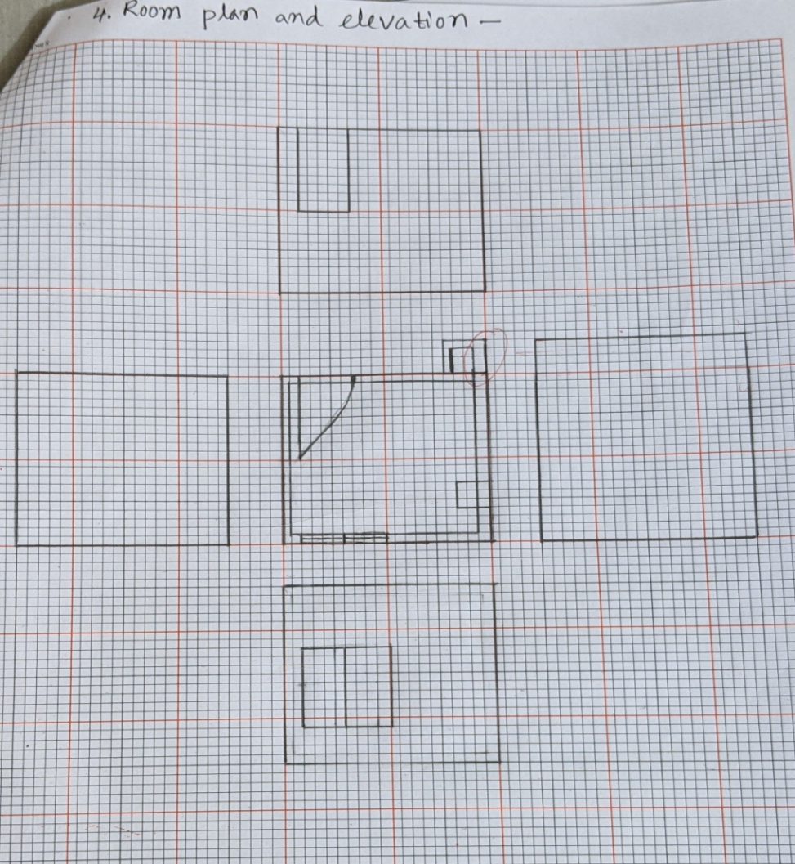

***Question Answer***

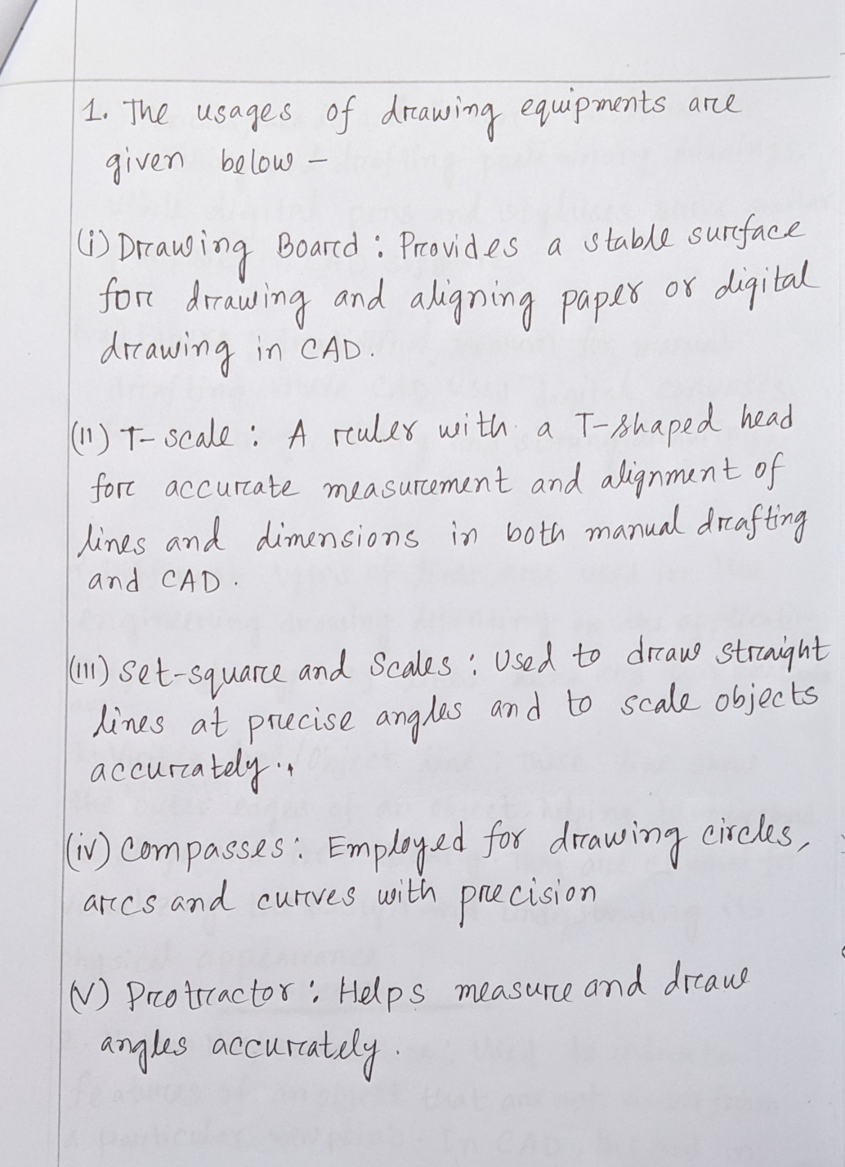

1. 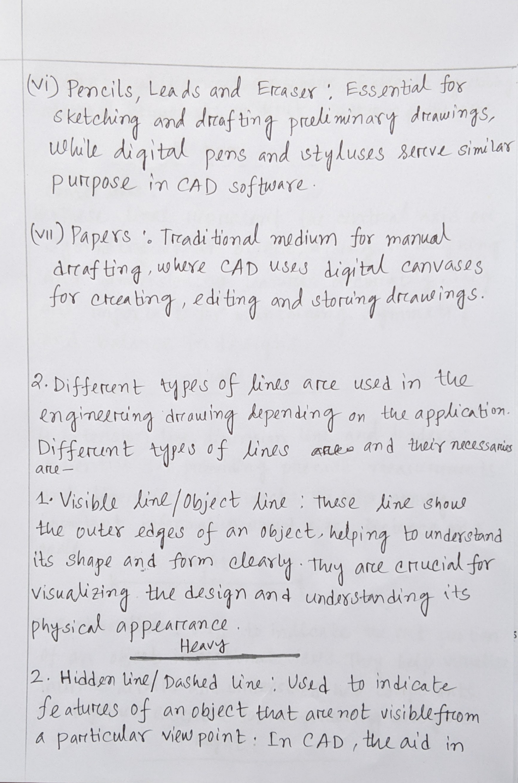

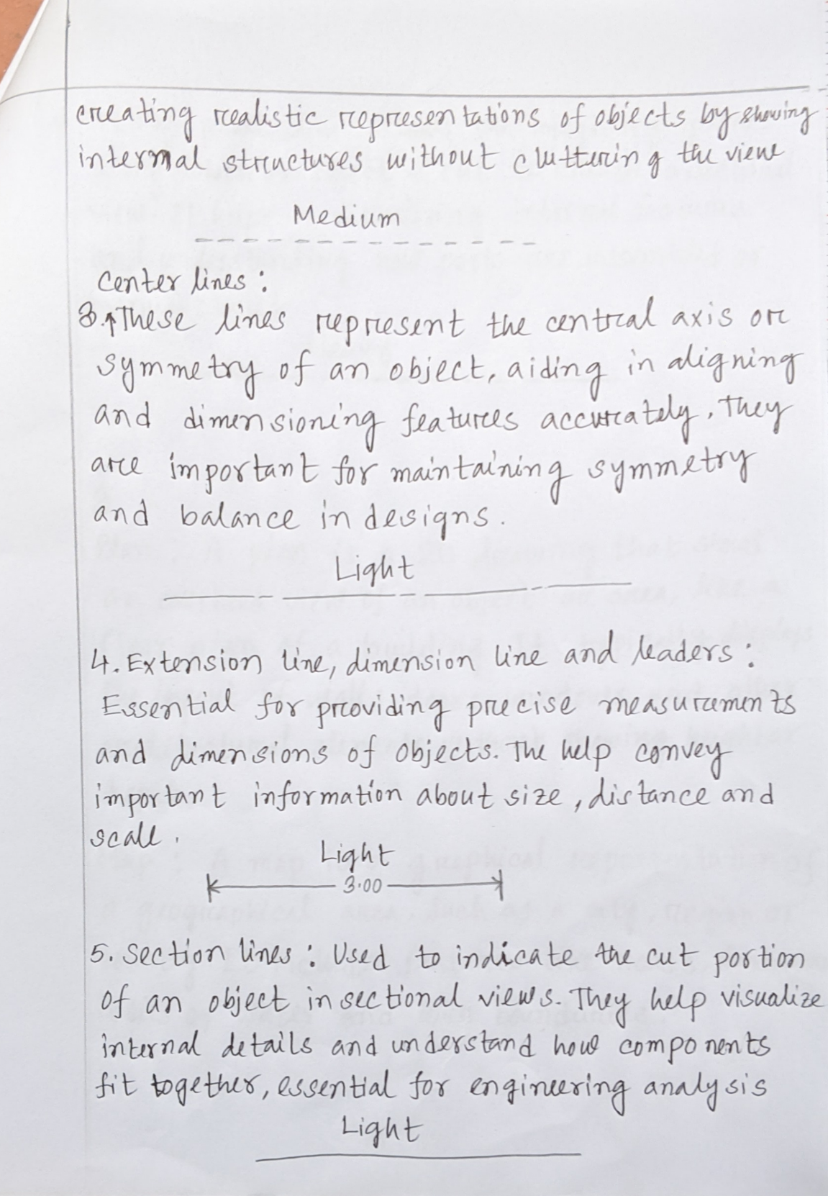

1. 